**INTER QUARTILE RANGE**

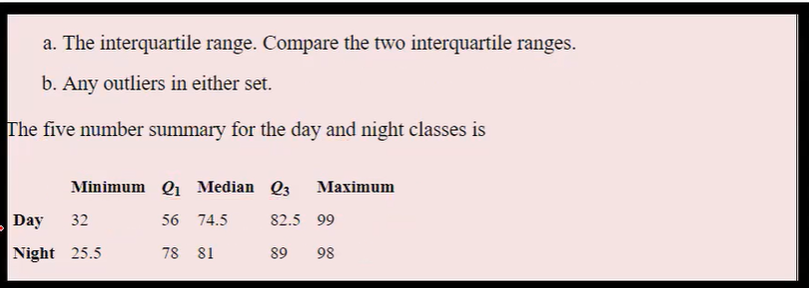

**Day:**

Q1=56

Q3=82.5

IQR=Q3-Q1

IQR=26.5

Lowest range = Q1-1.5*IQR

= 56-39.75

Lowest range = 16.25

**Rule for lower range:**

The minimum value in day should not present lower than the lowest range.

Min value in day = 32

32 is greater than 16.25, there is no outlier in lower range.

Highest range = Q3+1.5*IQR

= 82.5+ 39.75

Highest range = 122.25

**Rule for higher range:**

The maximum value in day should not present higher than the highest range.

Max value in day = 99

99 is less than 122.25, there is no outlier in higher range.



**Night:**

Q1=78

Q3=89

IQR=Q3-Q1

IQR=11

Lowest range = Q1-1.5*IQR

= 78-16.5

Lowest range = 61.5

**Rule for lower range:**

The minimum value in night should not present lower than the lowest range.

Min value in night = 25.5

25.5 is lesser than 61.5, there is outlier in lower range.

Highest range = Q3+1.5*IQR

= 89+ 16.5

Highest range = 105.5

**Rule for higher range:**

The maximum value in night should not present higher than the highest range.

Max value in night = 98

98 is less than 105.5, there is no outlier in higher range.

From above analysis, Outlier is present in night column lowest range.